PERSONA
PERceptive Spaces prOmoting iNdependent Aging

Service Gateway implementation and user guide
Deliverable number | (or internal report number)
WP number
WP title
Doc. Status | (draft, proposal, …)
Doc. Nature | (report, …)
Version
Actual date of delivery
Contractual date of delivery
Project start date | 01-01-2007
Project duration | 42 months
Approver
Authorizer
Editor

Authors
Partner Acronym | Partner Full Name | Person
VODIT | Vodafone Omnitel N.V | Mario Latronico

Modification Log
Version | Date | Author | Description
0.1 | 19/05/09 | Mario Latronico | First version with implementation and user guide
0.2 | 21/05/09 | Mario Latronico | Add instructions about pom.xml
0.3 | 20/07/09 | Mario Latronico | Added repositories for PaxWeb
0.4 | 05/11/09 | Mario Latronico | Updated login and dependencies part

For further information related to this Deliverable or to the PERSONA project please visit the project Web site http://www.aal-persona.org or contact the Project Coordinator.
Acronyms
PERSONA PERceptive Spaces prOmoting iNdependent Aging
Abstract
This document explains the implementation of the PERSONA Service Gateway used to access to the platform using an HTTP client. A tutorial to develop a web service using the Service Gateway is also provided.
Table of contents
1 Installation 7
1.1 Running 7
2 How to develop a service with the Service Gateway 8
2.1 Gateway Service Tracker 9
2.1.1 GatewayPort 9
2.1.2 Handling the login 10
2.2 Tutorial 10
2.2.1 Java part 11
2.2.2 Javascript and HTML part 12
2.2.3 Pom.xml 13
3 References 14

Installation
The PERSONA Service Gateway is available in the bundle persona.servicegateway and it runs on the server side of the PERSONA platform. Its dependencies are :
- org.osgi.compendium
- an Http Service implementation
- PaxLog implementation to log (and debug) events
The http service implementation used is the Pax Web one, available here http://wiki.ops4j.org/display/paxweb/Pax+Web .

Running
Since this component has only minimal dependencies, to run under Pax Cursor you only need few lines of provisioning, as in the following screenshot :

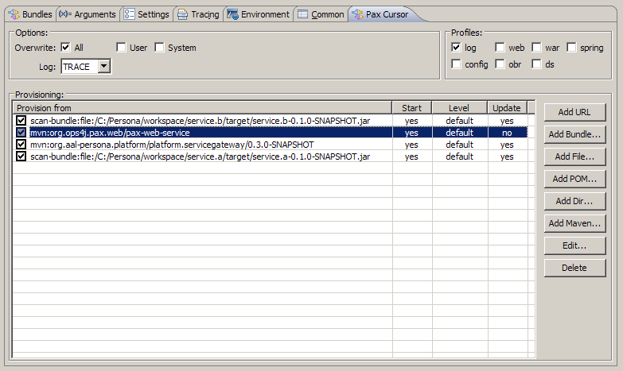
Figure 1 Pax Cursor configuration for Service Gateway

The profiles section has the log checkbox checked to automatically run the PaxLog bundles.
Service A and Service B are example bundles which implement the GatewayPort interface (see later for an explanation of the usage of this module) and are loaded by the Service Gateway. Alternatively, you can select also the web checkbox to download automatically the pax-web-service without having to specify it explicitly in the “Provisioning:” form.
To download the files you must add the following part in the .m2/settings.xml file, in the <repositories>… </repositories> section:
<repository>
<id>Pax</id>
<name>Pax</name>
<url>http://repository.ops4j.org/maven2</url>
<snapshots>
<enabled>true</enabled>
</snapshots>
</repository>

How to develop a service with the Service Gateway
The following diagrams and the following paragraphs explain how the Service Gateway is implemented and how to use it to create a web application to interact with the PERSONA platform.
First an explanation of the overall architecture is provided, then a brief tutorial explains how to build a servlet to be integrated in the PERSONA platform.

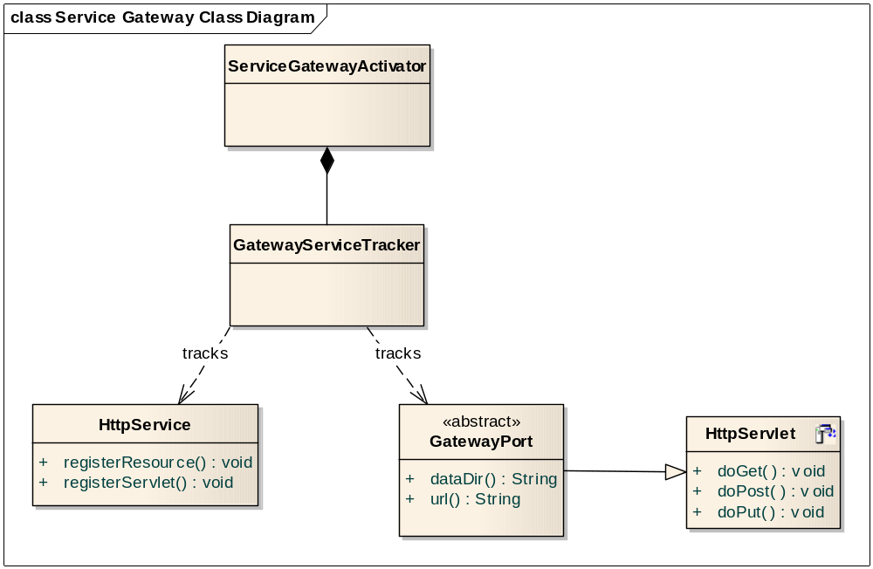
Figure 2 ServiceGateway class diagram

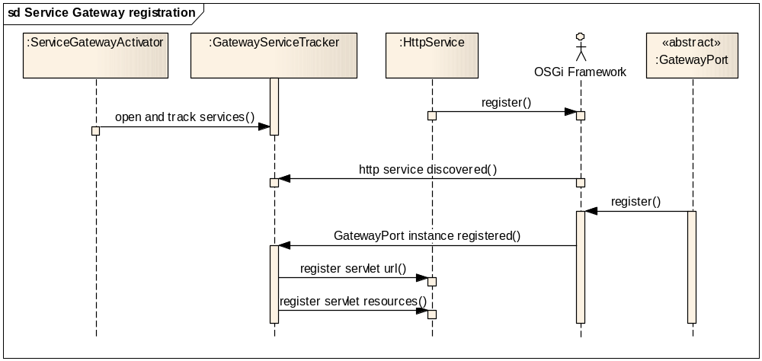
Figure 3 Servlet registration

Gateway Service Tracker
The core of this module is a specialization of the OSGi ServiceTracker [OSGiTrack], the GatewayServiceTracker, used to track the servlets that interact with the middleware. It is started by the Activator of the bundle platform.servicegateway.
It basically tracks two different types of services: the HttpService interface, implemented for example by Pax Web bundles, and the GatewayPort abstract class (see the next paragraph for an explanation of the its structure). The first provides a web server implementation and the second processes the request coming from a web client.
As soon as the HttpService is retrieved, the tracker gets its reference and then, when a class implementing the GatewayPort class is discovered, it registers that class as a servlet. A web client can then access to the url provided by the servlet.

GatewayPort
This class is very simple:

public abstract class GatewayPort extends javax.servlet.http.HttpServlet {
…
public abstract String url();
public GatewayPort ();
public abstract String dataDir();
…
public boolean handleLogin (HttpServletRequest req, HttpServletResponse resp);

}

The servlet must extend this class and provide the implementation of the abstract methods. The url() method is used to register the servlet access URL. It must start with a “/”. For example, if the method returns “/whereis” and the server address is ella.aal-persona.org, then the servlet is registered to the address http://ella.aal-persona.org/whereis .
The dataDir() method returns the logical directory where the resources are accessed.

The handleAuthorization () method is used to handle the login phase, as explained in the following paragraph. It returns
- true if the user is already logged in to the system
- false if it enters wrong username and password
It also presents a dialog asking for username and password in the initial phase. If the user has been previously registered to the system, a validation is performed then a redirection to the servlet pointed by the url() method is done, else the dialog is represented until a valid username / password pair is entered.

Handling the login
The login phase allow the access only to a limited set of registered users, using the profiling service to query the profiling database for a valid and registered user. In order to do this, the profiling service bundle and the MySQL server must be up and running (see the profiling service documentation to do that).
To handle the login, only few lines are required for each servlet extending GatewayPort :

if (handleAuthorization(req, resp) == false)
return;

It the handleAuthorization returns false, the servlet must return, else it can serve the content.

Tutorial
Let’s take the service “Help When Outside” as an example of a Gateway service user.
This service uses two servlets to provide its functionalities. The first is mapped to the url /whereis and it is used to track the elderly using a web browser. The second is mapped to the url /mapeditor and it is used to configure the service itself, for example, the safe area, the points of interest etc.
The source tree is shown in the following image snapshot:

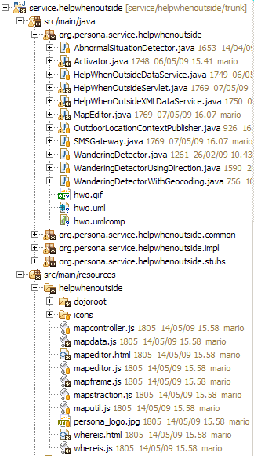

Figure 4 The source tree of the Help When Outside application

This service has a Java code part under the tree src/main/java and an HTML and Javascript part under the tree src/main/resources. Both will be described in the following paragraphs.

Java part
The core of the service is in the HelpWhenOutsideServlet and MapEditor classes. Since they use the same pattern only the HelpWhenOutsideServlet will be described.

public class HelpWhenOutsideServlet extends GatewayPort {
…
public void doGet(HttpServletRequest req, HttpServletResponse resp)
throws ServletException, IOException
{
…
}
public void doPost(HttpServletRequest request, HttpServletResponse response)throws ServletException, IOException
{
…
}
public String url() {
return “/whereis”;
}
public String dataDir() {

return "/helpwhenoutside";
}

…
} // end of the class

The url() and dataDir() are implemented because this class extends GatewayPort, and the doGet() and doPost() are overridden to handle the HTTP POST and GET requests (of course all methods from the class HttpServlet can be overridden). The dataDir() purpose will be clarified in the next paragraph.

The Activator class, when the bundle is started, registers the servlet as a GatewayPort instances :

HelpWhenOutsideServlet serviceServlet =
new HelpWhenOutsideServlet( … );

context.registerService(GatewayPort.class.getName(), serviceServlet, null);

This way, the servlet can be tracked by the ServiceTracker and registered to the web server. Any HTTP GET to http://ip-address/whereis will be answered by the method doGet() of the HelpWhenOutside servlet. If the servlet requires a restricted access, the code specified in the paragraph 2.1.2 should be used.

Javascript and HTML part
Under the src/main/resources directory there is the HTML and JavaScript code and all the resources that will be delivered by the web server to the web client.
One important assumption is followed: all the resources must be placed under the directory specified by the dataDir() method in the GatewayPort implementation. In this case the directory is “/helpwhenoutside” as you can see in Figure 4 and in the previous snippet of code.
All the HTML and JavaScript code must refer to this logical directory, for example the whereis.html has :

<html>
<head>
<meta http-equiv="Content-Type" content="text/html; charset=UTF-8" />
<title>PERSONA Help When Outside - Follow the user</title>
<style type="text/css">
@import "/helpwhenoutside/dojoroot/dijit/themes/soria/soria.css";
</style>
<script type="text/javascript" src="/helpwhenoutside/dojoroot/dojo/dojo.js.uncompressed.js">
</script>
…
…

<img src="/helpwhenoutside/icons/safearea.png" height="48" width="48" />
…
…
</html>

This is required because when the servlet is registered, also its resources are registered under the dataDir() path.

Pom.xml
The pom.xml has to include some directives to take advantage of the latest servlet specifications and to include the resources in the .jar file.
In the <dependencies> section the org.osgi.compendium must be included, but the javax.servlet part must be excluded to use a newer specification version (in a later <dependency> section) :

<dependency>
<groupId>org.apache.felix</groupId>
<artifactId>org.osgi.compendium</artifactId>
<version>1.2.0</version>
<exclusions>
<exclusion>
<artifactId>javax.servlet</artifactId>
<groupId>org.apache.felix</groupId>
</exclusion>
</exclusions>
</dependency>

The java.servlet api and the package platform.servicegateway must be included as well :

<dependency>
<groupId>javax.servlet</groupId>
<artifactId>servlet-api</artifactId>
<version>2.5</version>
</dependency>

<dependency>
<groupId>org.aal-persona.platform</groupId>
<artifactId>platform.servicegateway</artifactId>
<version>[0.3.5,]</version>
<type>bundle</type>
</dependency>

Make attention to the versions, your mileage may vary.
After that, in the <maven-bundle-plugin> section you must set the <Include-Resource> and the <Import-Package> directives:

<Include-Resource>
src/main/resources
</Include-Resource>
<Import-Package>
javax.servlet;version="2.5.0",
javax.servlet.http;version="2.5.0",
org.osgi.framework,
org.osgi.service.http,
org.osgi.util.tracker,
org.slf4j,
…
</Import-Package>

References
[OSGiTrack] OSGi ServiceTracker Java API , version 4.1, http://www.osgi.org/javadoc/r4v41/org/osgi/util/tracker/ServiceTracker.html

